CS4093 - Assignment 1
Alexander Stradnic - 119377263
XOR : An Exclusive OR gate works in a similar manner to OR, except that it only activates on one of the inputs only, not both.

A | B | Y | 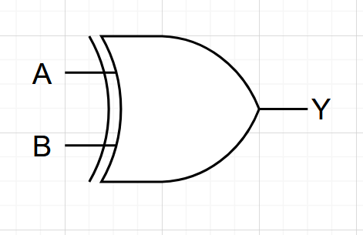
0 | 0 | 0
0 | 1 | 1
1 | 0 | 1
1 | 1 | 0

Verilog Code
module xor_gate (c,a,b);
input a,b;
output c;
assign c = a^b;
endmodule

Testbench Code
module xorgate;
reg a;
reg b;
wire c;
xor_gate TEST(.c(c), .a(a), .b(b));
initial begin
$dumpfile("dump.vcd");
$dumpvars(1);
a=0;
b=0;
#10;
a=0;
b=1;
#10;
a=1;
b=0;
#10;
a=1;
b=1;
#10;
end
endmodule

Waveform

NAND : A NAND gate works by inverting the output taken from an AND gate.

A | B | Y | 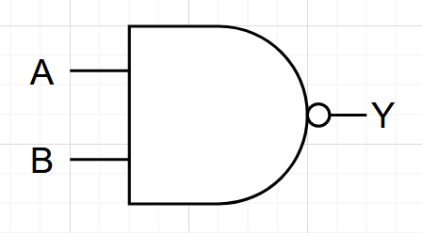
0 | 0 | 1
0 | 1 | 1
1 | 0 | 1
1 | 1 | 0

Verilog Code
module nand_gate (c,a,b);
input a,b;
output c;
assign c = !(a&b);
endmodule

Testbench Code:
module nandgate;
reg a;
reg b;
wire c;
nand_gate TEST(.c(c), .a(a), .b(b));
initial begin
$dumpfile("dump.vcd");
$dumpvars(1);
a=0;
b=0;
#10;
a=0;
b=1;
#10;
a=1;
b=0;
#10;
a=1;
b=1;
#10;
end
endmodule

Waveform

NOR : A NOR gate works by inverting the output from an OR gate.

A | B | Y | 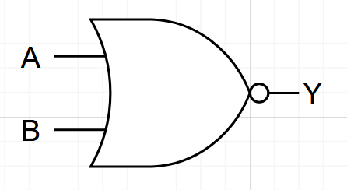
0 | 0 | 1
0 | 1 | 0
1 | 0 | 0
1 | 1 | 0

Verilog Code
module nor_gate (c,a,b);
input a,b;
output c;
assign c = !(a|b);
endmodule

Testbench Code
module norgate;
reg a;
reg b;
wire c;
nor_gate TEST(.c(c), .a(a), .b(b));
initial begin
$dumpfile("dump.vcd");
$dumpvars(1);
a=0;
b=0;
#10;
a=0;
b=1;
#10;
a=1;
b=0;
#10;
a=1;
b=1;
#10;
end
endmodule

Waveform

SR FLIP FLOP : An SR flip-flop can store a 1-bit value, and operates using 2 NAND gates. An input is designated as the setter (S) with the other input being the resetter (R).

S | R | Q | Q’ | State
0 | 0 | Q | Q’ | No change
1 | 0 | 1 | 0 | Set
0 | 1 | 0 | 1 | Clear
1 | 1 | X | X | Invalid
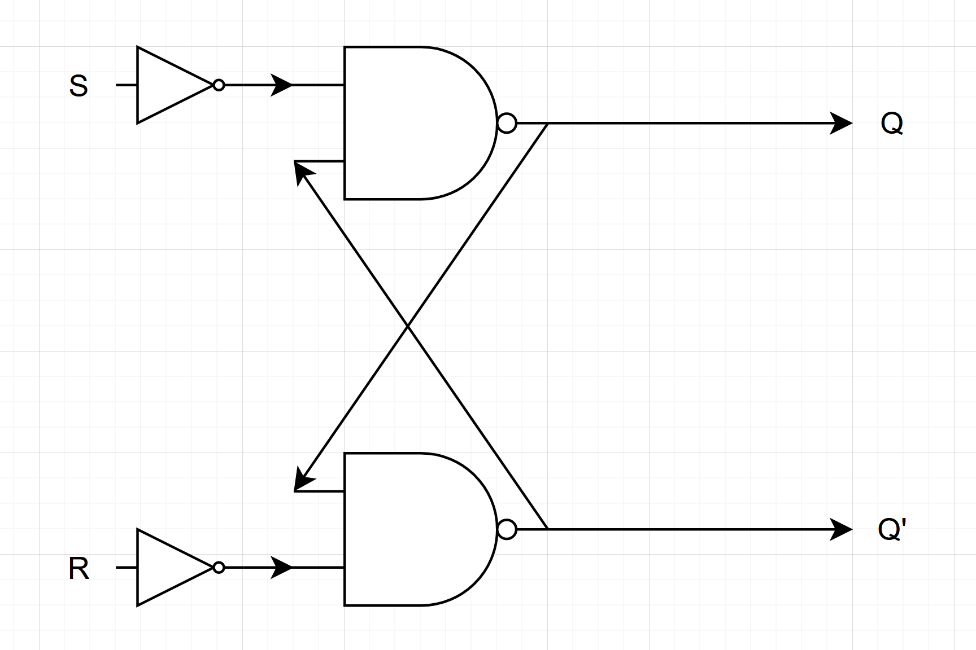
Verilog Code
module sr_flipflop(q,qbar,clk,s,r);
input clk;
input s;
input r;
output q,qbar;
reg q,qbar;
always @(posedge clk) begin
if (r == 0 && s==0) begin
q <= q;
qbar <= qbar;
end else if (s == 1 && r == 0) begin
q <= 1;
qbar <= 0;
end else if (s == 1 && r == 1) begin
q <= 1'bx;
qbar <= 1'bx;
end else if (s == 0 && r == 1) begin
q <= 0;
qbar <= 1;
end
end
endmodule

Testbench Code
module TEST;
reg clk,s,r;
wire q,qbar;
sr_flipflop TEST (.q(q), .qbar(qbar), .clk(clk), .s(s),.r(r));
initial begin
$dumpfile("dump.vcd");
$dumpvars(1);
clk=1; // initial
r = 0;
s = 0;
#10;
clk=0; // set but clock inactive
r = 0;
s = 1;
#10;
clk=1; // clock active, thus set works
#10;
clk=0; // reset but clock inactive
r = 1;
s = 0;
#10;
clk = 1; // reset activates
#10;
clk = 0;
s = 1; // bad state but not active
#10;
clk = 1; // bad state activated
#10;
end
endmodule

Waveform

JK FLIP FLOP : A JK flip-flop can store a 1-bit value, and operates using 2 NAND gates, in a similar manner to the SR flip-flop. The JK Flip-flop overcomes the issue with the SR flip-flop where the state is invalid when both inputs are set to 1 by flipping the state of the outputs in that instance.

J | K | Q | Q’ | State
0 | 0 | Q | Q’ | No change
1 | 0 | 1 | 0 | Set
0 | 1 | 0 | 1 | Clear
1 | 1 | ~Q | ~Q’ | Toggle State
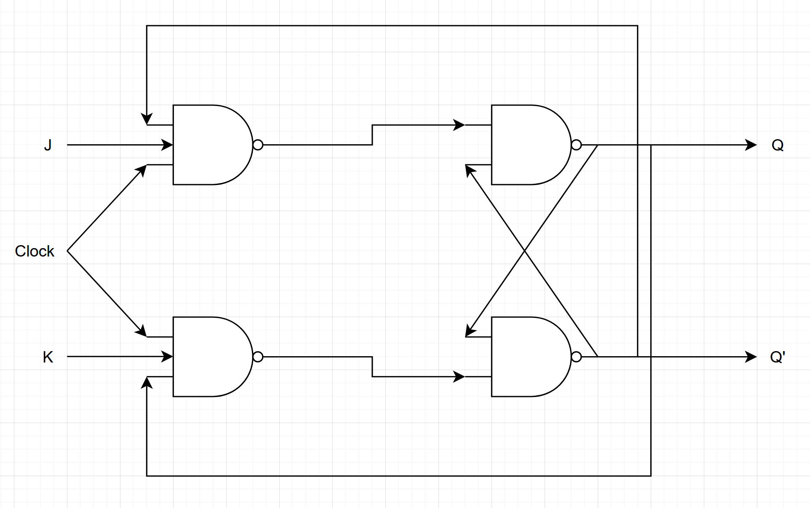
Verilog Code
module jk_flipflop(q,qbar,clk,j,k);
input clk;
input j;
input k;
output q,qbar;
reg q,qbar;
always @(posedge clk) begin
if (j==0 && k==0) begin
q <= ~q;
qbar <= ~qbar;
end else if (j == 1 && k == 0) begin
q <= 1;
qbar <= 0;
end else if (j == 1 && k == 1) begin
q <= ~q;
qbar <= ~qbar;
end else if (j == 0 && k == 1) begin
q <= 0;
qbar <= 1;
end
end
endmodule

Testbench Code
module TEST;
reg clk,j,k;
wire q,qbar;
jk_flipflop TEST (.q(q), .qbar(qbar), .clk(clk), .j(j),.k(k));
initial begin
$dumpfile("dump.vcd");
$dumpvars(1);
clk=1; // initial
j = 0;
k = 0;
#10;
clk=0; // set but clock inactive
j = 0;
k = 1;
#10;
clk=1; // clock active, thus set works
#10;
clk=0; // reset but clock inactive
j = 1;
k = 0;
#10;
clk = 1; // reset activates
#10;
clk = 0;
k = 1; // bad state but not active
#10;
clk = 1; // bad state activated
#10;
end
endmodule

Waveform

T FLIP FLOP : An T flip-flop can store a 1-bit value, and flips with the input (AND clock if relevant).

T | Q | Q’ | State
0 | Q | Q’ | Hold State
1 | ~Q | ~Q’ | Toggle State
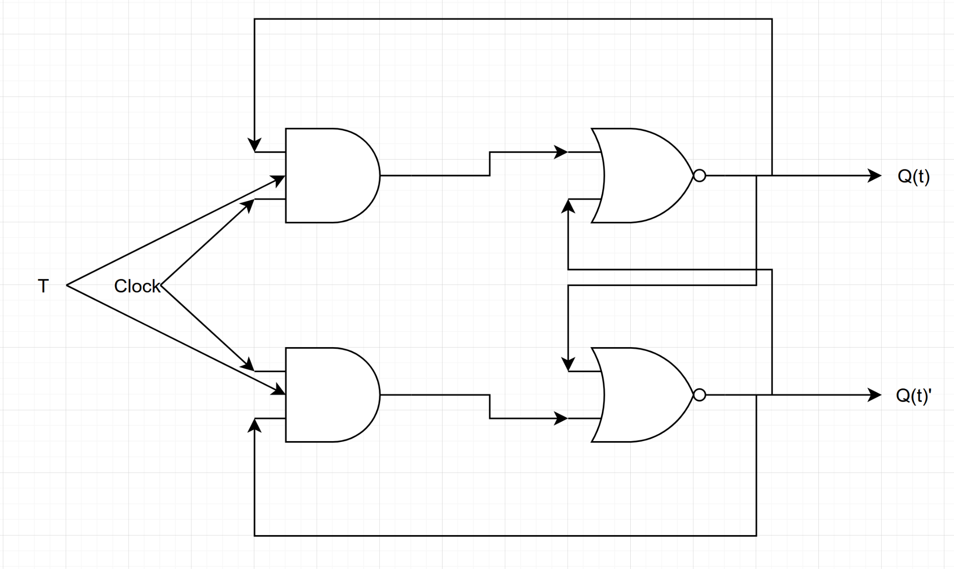

Verilog Code
module t_flipflop(q,qbar,clk,t);
input clk;
input t;
output q,qbar;
reg q,qbar;
always @(posedge clk) begin
if(q === 1'bx) begin
q <= 1;
qbar <= 0;
end else if (t == 0) begin
q <= q;
qbar <= qbar;
end else if (t == 1) begin
q <= ~q;
qbar <= ~qbar;
end
end
endmodule

Testbench Code
module TEST;
reg clk,t;
wire q,qbar;
t_flipflop TEST (.q(q), .qbar(qbar), .clk(clk), .t(t));
initial begin
$dumpfile("dump.vcd");
$dumpvars(1);
clk=1; // initial
t = 0;
#10;
clk=0; // toggle but clock inactive
t = 1;
#10;
clk=1; // clock active, thus toggle works
#10;
clk=0; // hold but clock inactive
t = 0;
#10;
clk = 1; // hold 'activates'
#10;
clk = 0;
t = 1; // toggle but not active
#10;
clk = 1; // toggle state activated
#10;
end
endmodule

Waveform

